**Bellabeat Case Study Report**

**Introduction:**

This report aims to assist Bellabeat, a high-tech manufacturer of health-focused products for women, in understanding their fitness watch users better and suggesting marketing strategies for acquiring new customers.

To achieve this, I analyzed a dataset generated by respondents to a survey distributed via Amazon Mechanical Turk from 12th March, 2016 to 12th May, 2016. The dataset consisted of personal tracker data, including minute-level outputs for physical activity, heart rate, and sleep monitoring of 30 different users.

Note that in the analysis, data for the entire duration was only used in Figure 1 and while analyzing sleep quality. For rest of the analysis, only data from 12th March, 2016 to 11th April, 2016 was analyzed because analyzing the data for the next 30 days of the time window would not have any significant influence on achieving the business task at hand.

**Analysis:**

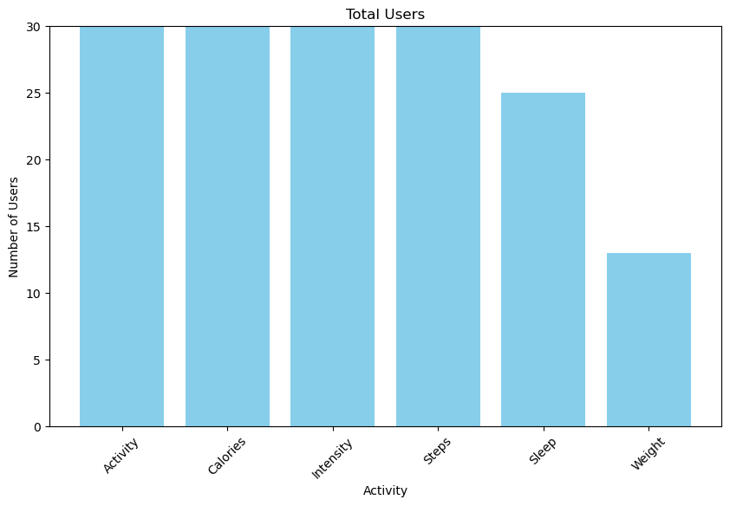

Figure

1. Weight:

Figure 1 illustrates the distribution of different types of data contributed by users. It reveals that most functionalities of the watch were utilized by all users, enabling them to contribute data. For instance, activity data was recorded by all 30 users, indicating that everyone used their watch for activity tracking. However, there were exceptions in sleep and weight data contributions. Notably, only about half of the users contributed weight data, suggesting either a lack of use for weight tracking or discomfort in sharing this information publicly.

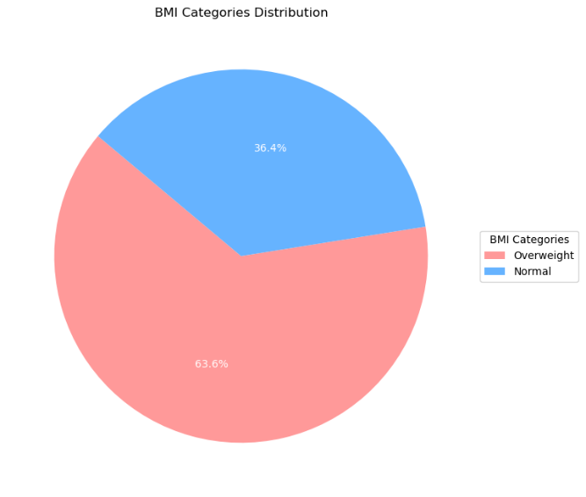

Delving deeper into those who contributed weight data, it was found that most were overweight. This assessment was based on BMI thresholds from the WHO: underweight (below 18.5), normal (18.5-24.9), and overweight (greater than 24.9). This indicates that overweight individuals are more likely to track their weight using the watch. This is illustrated in Figure 2

An analysis was also conducted on users' ability to achieve weight goals with the watch. Weight goals were defined as underweight individuals increasing calorie intake, normal-weight individuals maintaining it, and overweight individuals reducing it. The analysis revealed that no users achieved their weight goals within the two-month data period.

Figure

1. Sleep:

The sleep quality of watch users was analyzed by determining if they received at least seven hours of sleep per day. Users meeting this criterion were classified as good sleepers. Figures 3 and 4 display the percentage of good sleepers over two months, revealing a consistent trend without noticeable improvement in sleep quality among watch users. Additionally, the data highlights the prevalent issue of poor sleep quality, with only about 60% achieving good sleep on most days.

Figure 4

Figure 3

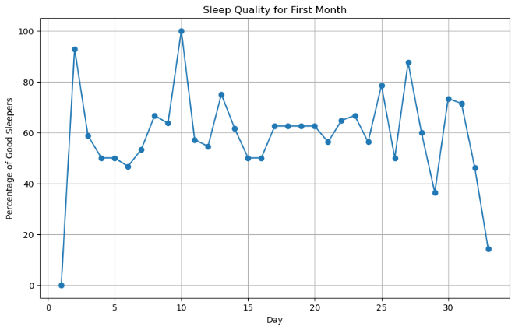

1. Activity Intensity:

The intensity of activities performed by users while wearing the watch was analyzed by calculating the percentage of time activities of varying intensities were recorded, such as sedentary, across all the users. The results, shown in Figure 5, indicate that the majority of recorded activity is sedentary, with low-intensity activities comprising the second largest portion of the time users wear their watches.

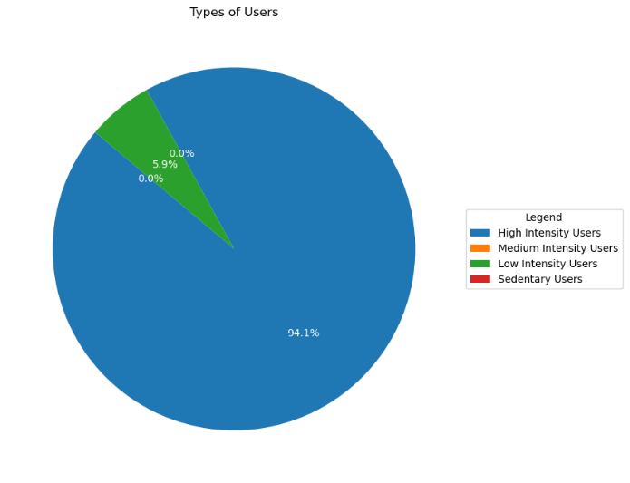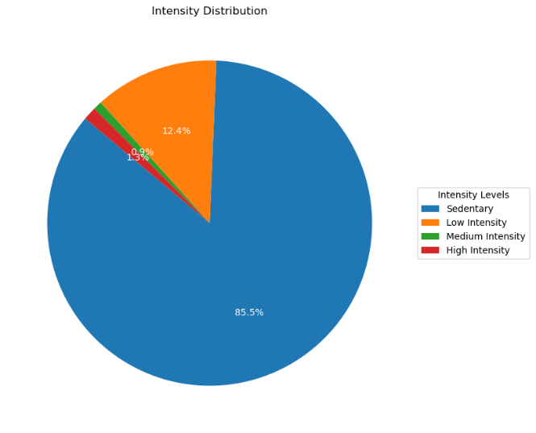

Figure 6

Figure 5

The types of users who wear the watch were analyzed, as shown in Figure 6. High-intensity users are those who performed a high-intensity activity at least once while wearing the watch. Medium-intensity users engaged in medium-intensity activities at least once but were never recorded as performing high-intensity activities. The pie chart in Figure 6 indicates that high-intensity users make up the majority of the watch's user base.

1. Heart Rate:

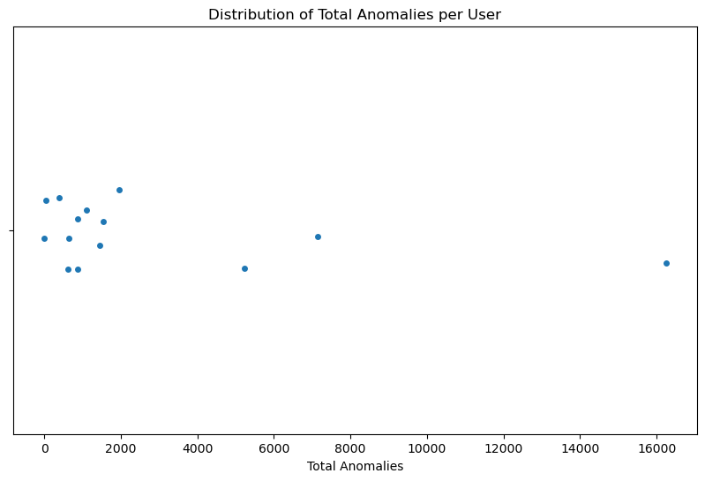

Figure 7

Heart rate anomalies were analyzed for users wearing the watch. Anomalies are defined as instances of abnormally fast (tachycardia) or slow (bradycardia) heart rates. Heart rates were checked against different thresholds depending on activity level. While sedentary, users were classified as bradycardic if their heart rate dropped below 50 beats per minute and tachycardic if it exceeded 100 bpm. During high-intensity activities, a heart rate below 110 bpm was considered abnormally low, and above 180 bpm was classified as tachycardic.

The scatter plot shows the number of anomalies detected for the 14 users who contributed heart rate data. The results indicate a high number of anomalies for most of the users, ranging from about 1,000 to 16,000 instances for different users. Moreover, there was only one user for whom an anomaly was not detected in the heart rate data for the first 30 days. This highlighs the importance of this feature for potentially life-saving insights as many users suffer from heart rate patterns that might indicate underlying diseases.

**Conclusions and Recommendations:**

The analyses above lead to several conclusions. The BMI distribution in Figure 2 suggests that a significant customer base for fitness watches consists of overweight individuals. Therefore, Bellabeat should target people looking to reduce their weight by advertising how their product, Time, can help users achieve their goals. Additionally, most Fitbit users struggle to meet their calorie goals. Bellabeat could research the reasons behind this and enhance Time to better support users in achieving these goals.

Figures 3 and 4 reveal that sleep quality is a major issue among Bellabeat’s target customers, and current devices do not significantly improve it. Bellabeat could enhance sleep-related features and run awareness campaigns about the importance of good sleep. This approach would demonstrate the brand's commitment to customer well-being.

The pie chart in Figure 5 indicates that users likely wear their watches continuously, not just during exercise sessions. This suggests that Bellabeat should focus on both fitness and regular watch features like battery life, comfort, and design. Emphasizing these aspects could attract users who currently wear regular watches by offering additional health benefits.

Furthermore, Figure 6 shows that most fitness watch users engage in high-intensity activities at some point. Bellabeat could market features of Time that make it suitable for activities like exercising, such as water, sweat, and dust resistance, and Bluetooth connectivity for music. If there are additional features that could enhance the user experience during high-intensity activities, Bellabeat should consider incorporating them.

The number of heart rate anomalies detected in Figure 7 highlights the importance of this feature in fitness watches. Bellabeat should ensure robust heart rate monitoring and advertise its potential life-saving benefits.

Overall, these insights provide valuable directions for product development and marketing strategies to help Bellabeat increase its market share in the fitness watch industry.

**Potential Improvements:**

There are several improvements that can enhance our confidence in the conclusions and help us better understand fitness watch users. Increasing the number of users from whom data is collected would strengthen our conclusions, particularly regarding weight, as only about 13 users contributed weight data, which is quite low. Additionally, recording more personal information, such as height and body fat percentage, could provide a more precise determination of whether a person is overweight or underweight.

Moreover, asking users directly about their calorie goals would offer more accurate insights, as current estimates are based on BMI, which may not reflect individual aspirations. For instance, an overweight person might be content with their weight and aim to maintain it rather than reduce it.

Finally, collecting age data is crucial because normal heart rates vary with age. This information would improve the precision of heart rate anomaly detection.